**TJD GUI – User Guide**

1. The first step before using TJD is to **modify the parameters_distanceS.m** file. Here you will specify the computer name, animal name, directories, hole and track number, etc., as shown in the figure below. **The variable called “x.list_data_name” must not be modified** as it will be updated according to the animal’s name specified before.

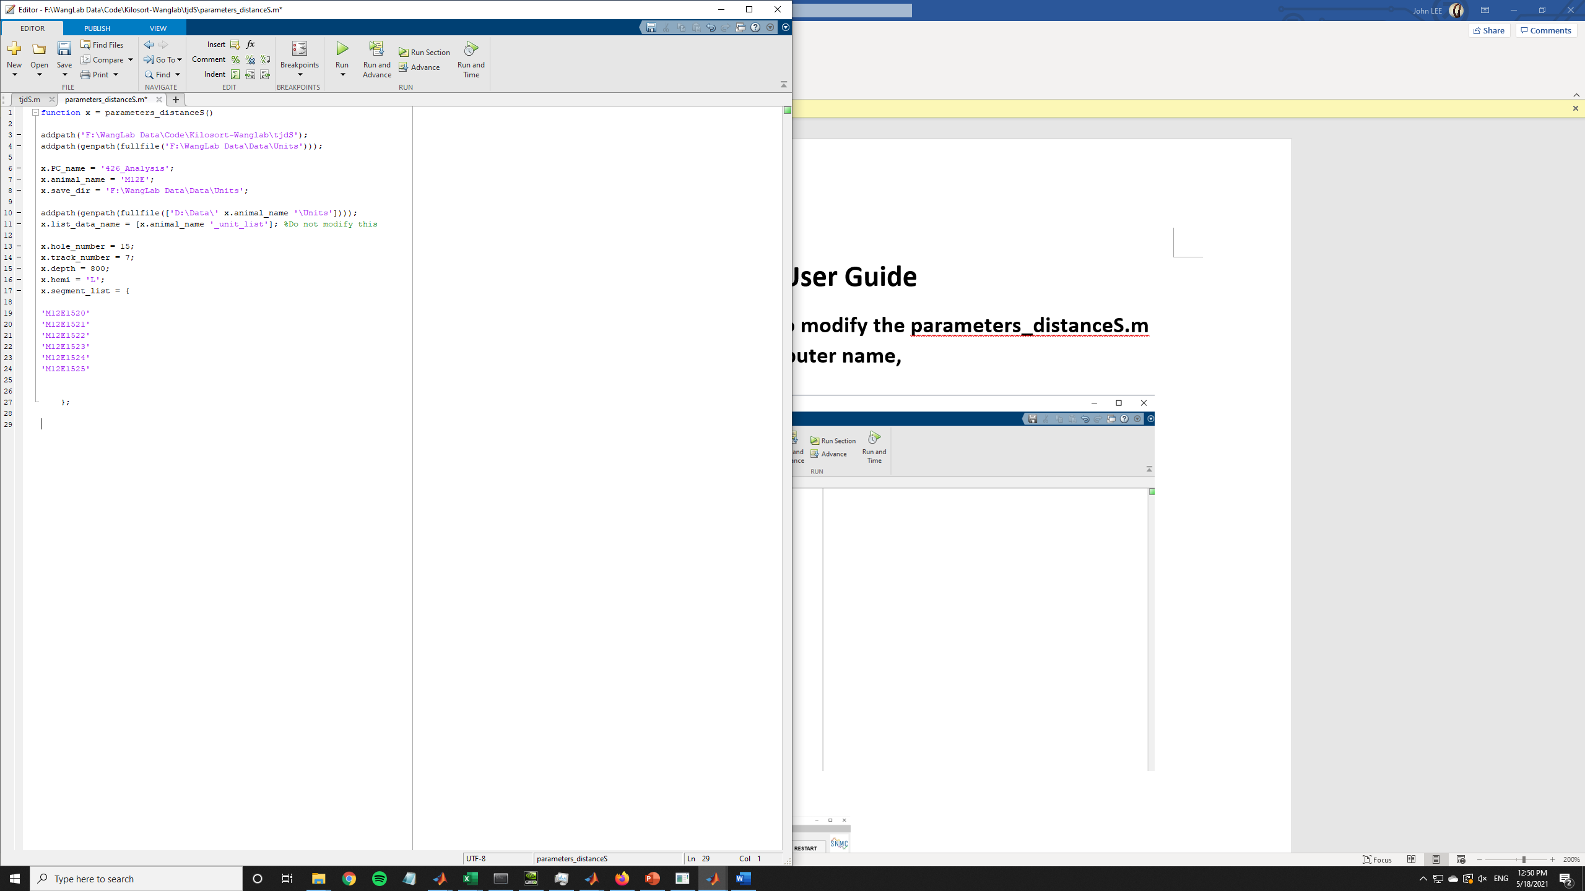

1. After modifying the parameters file, now you can proceed and run the TJD code. After initializing the TJD code and running the Cdistance function, the TJD GUI will pop up and you will see the screen of the figure below. As you can see most of the buttons are locked to prevent user errors.

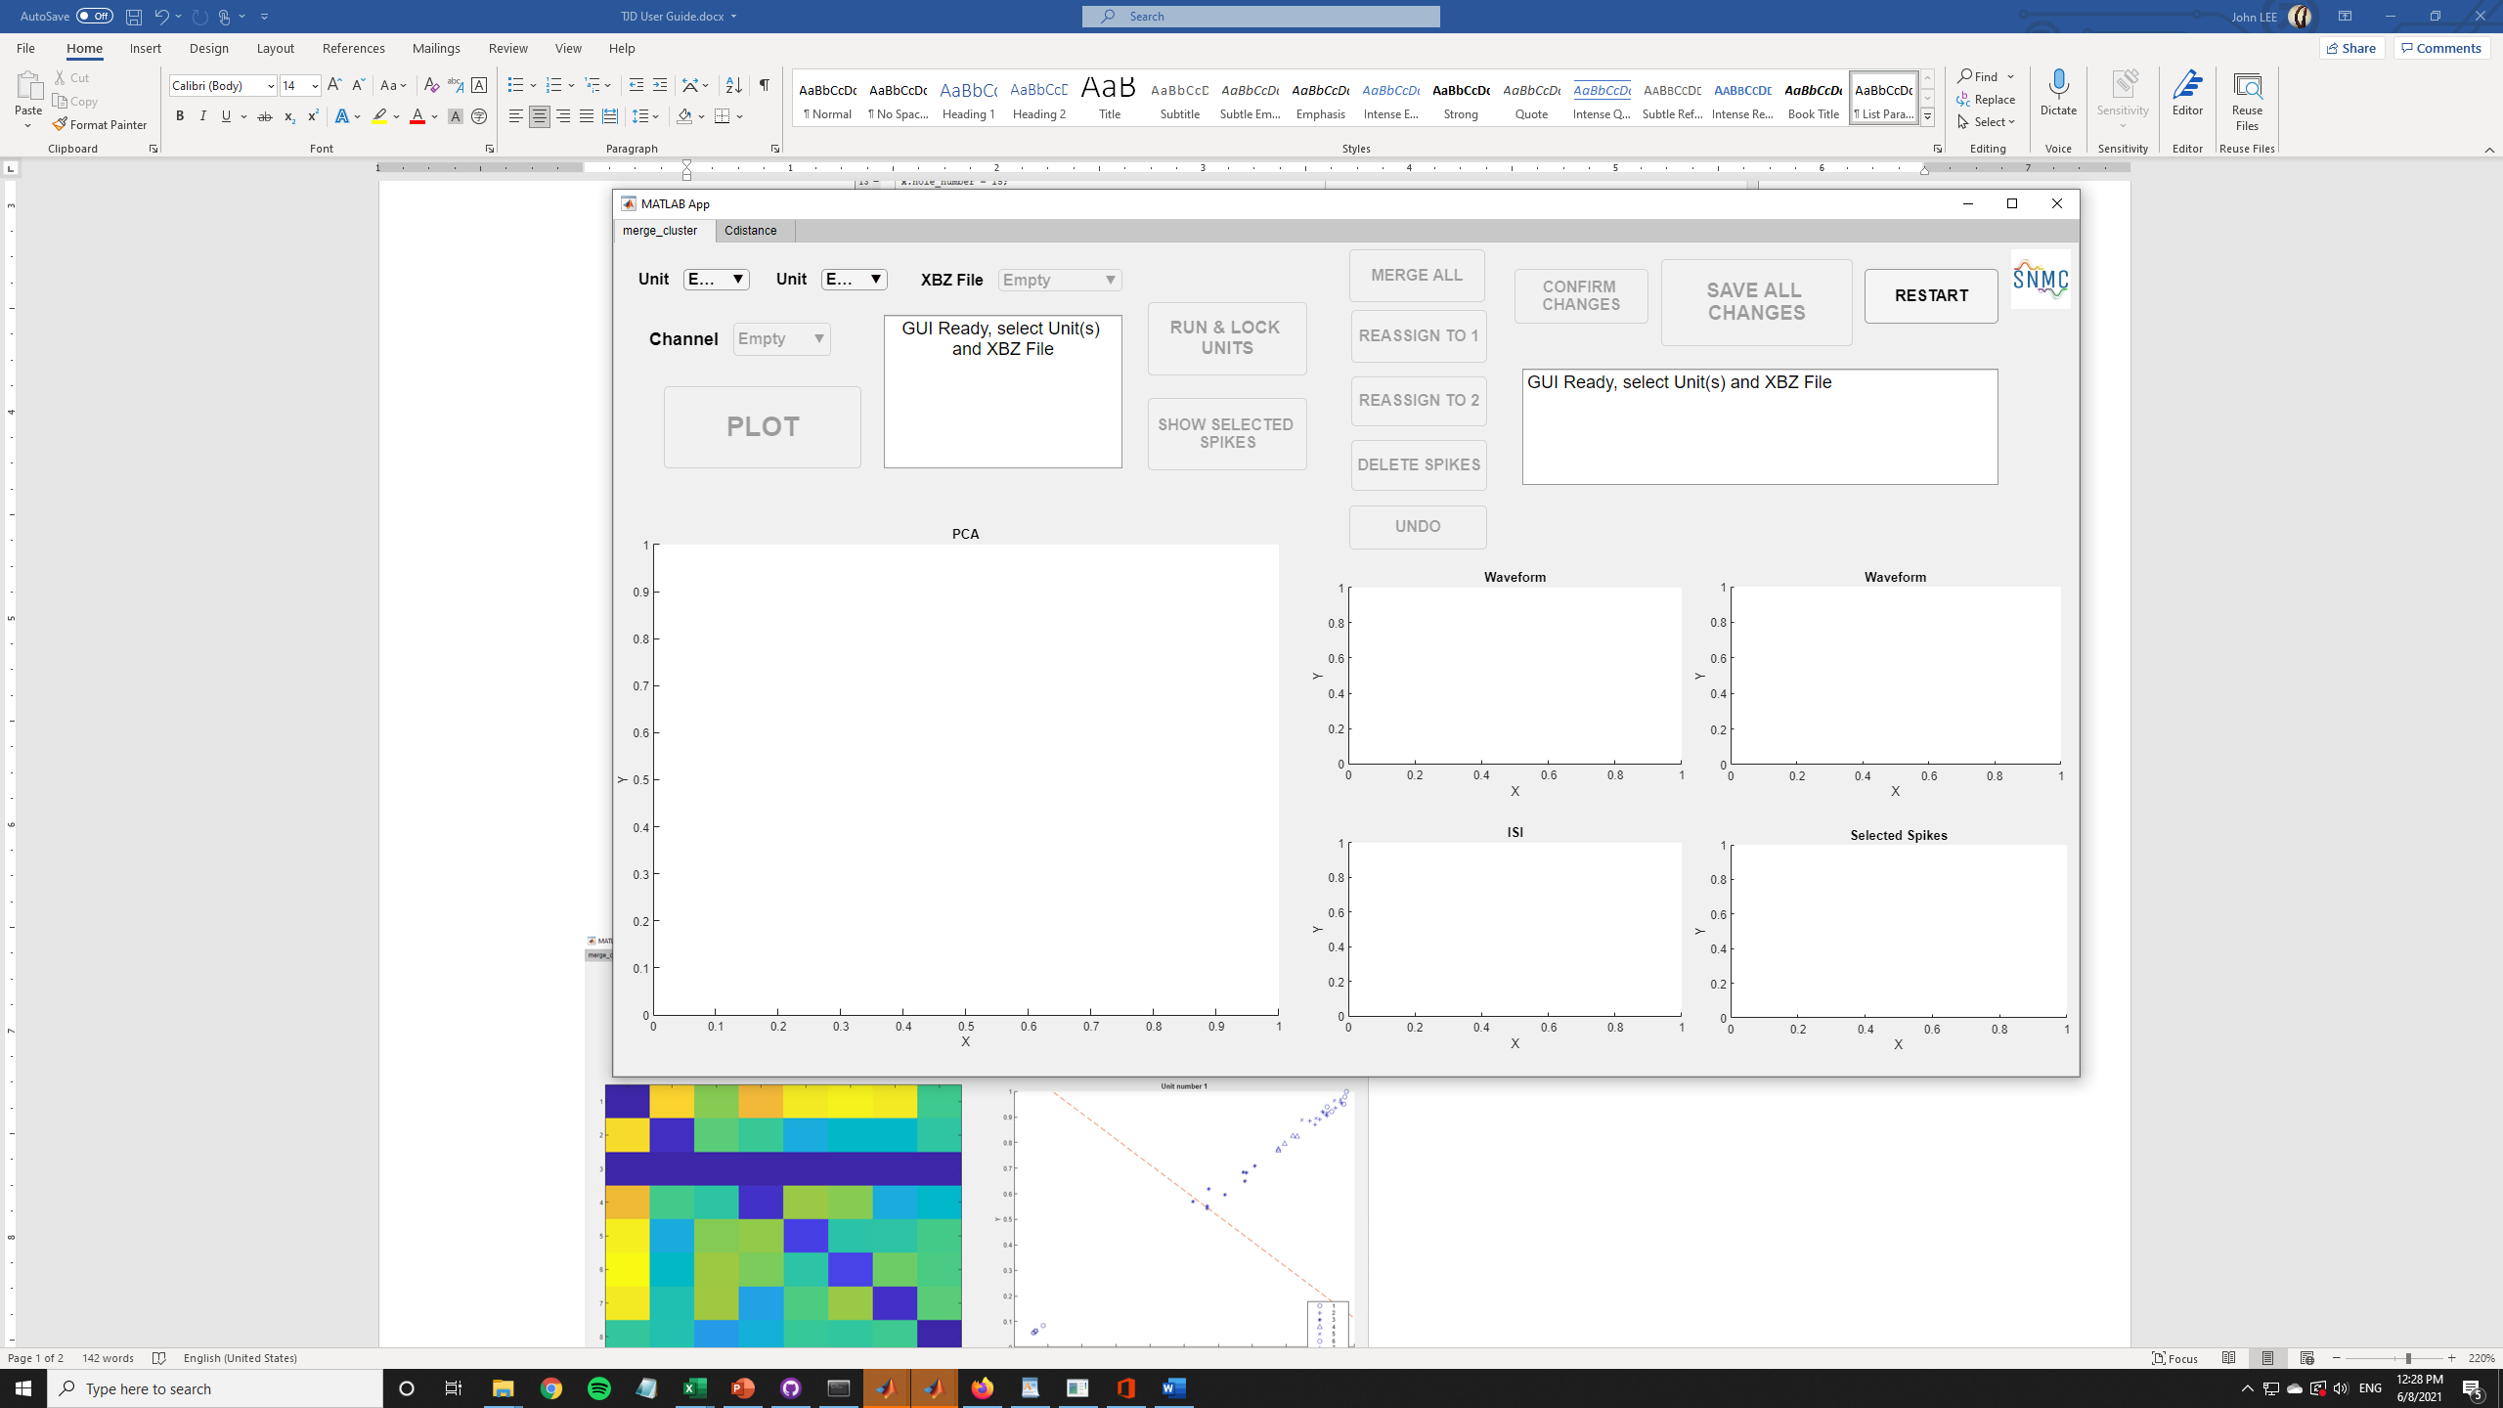

1. The GUI consists of 2 windows: one for the manual modification/quality analysis of clusters, and one for the visualization of cluster distances (figure below).

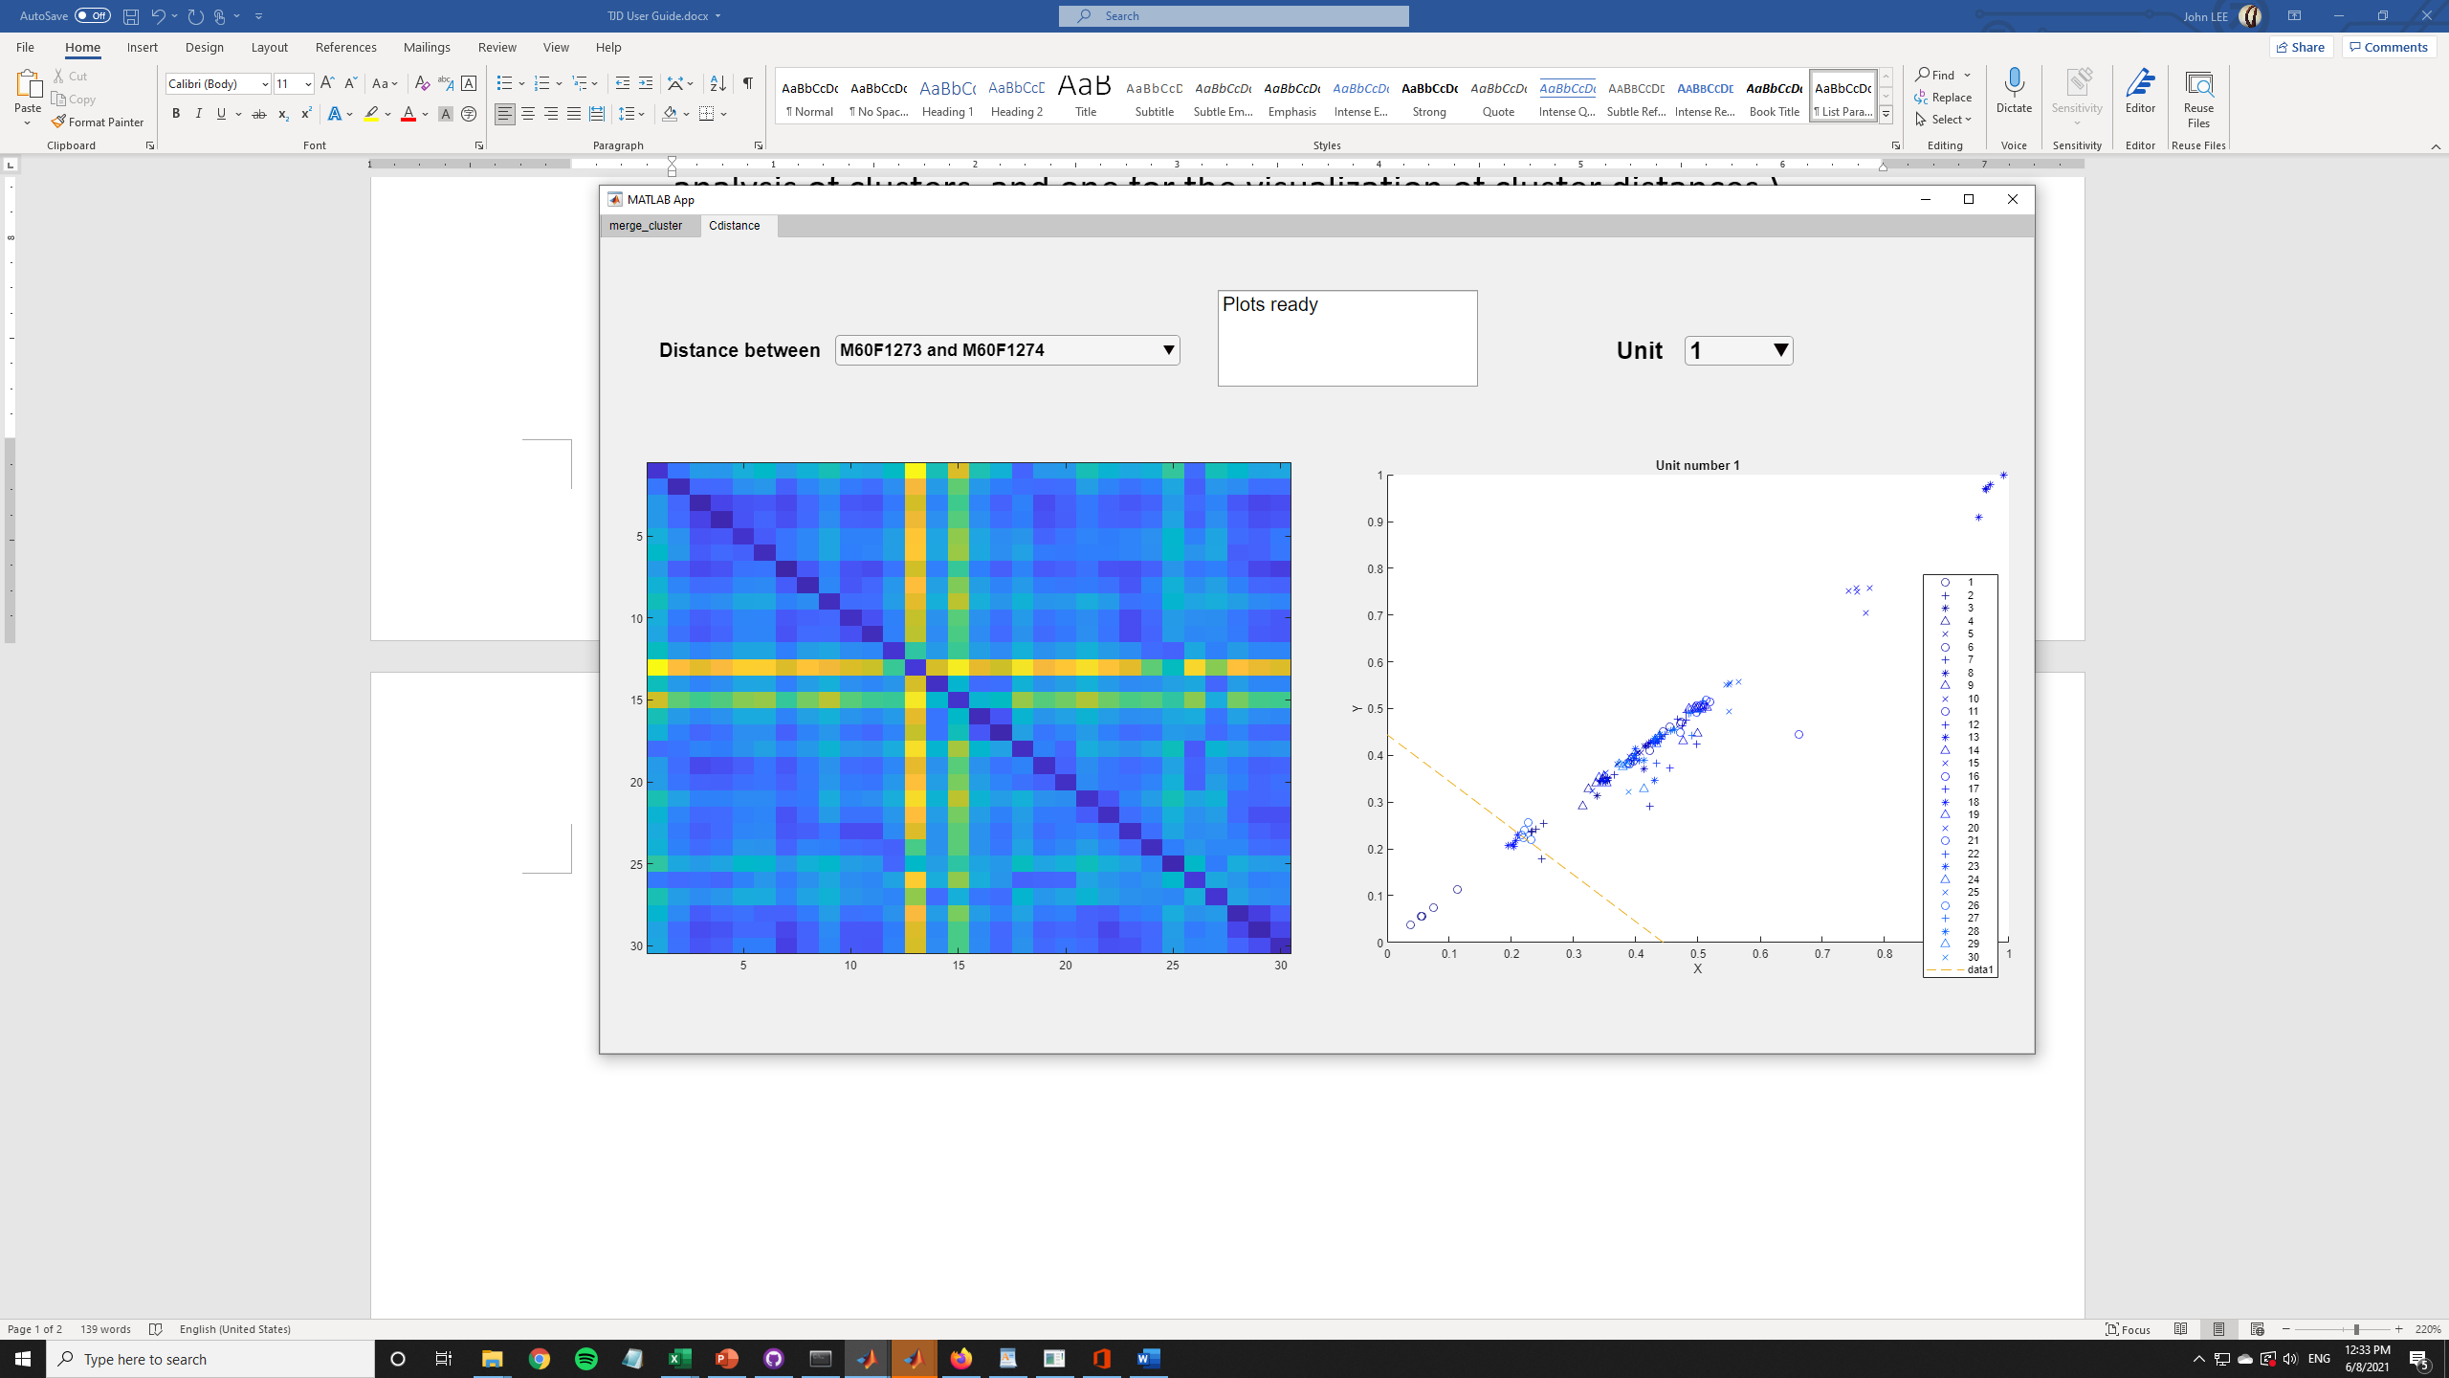

1. In the **merge_cluster** window (figure below) you can select either 1 or 2 units, the desired XBZ file and the best channel for the visualization of the data. After plotting the units, you will be able to select spikes from the PCA plot space and decide if you want to merge all spikes, reassign them, or delete them. Please note: once you press RUN & LOCK UNITS you won’t be able to select different units, this in order to save the data correctly. If you want to select different units, press the RESTART button, but be aware this will delete all changes made.

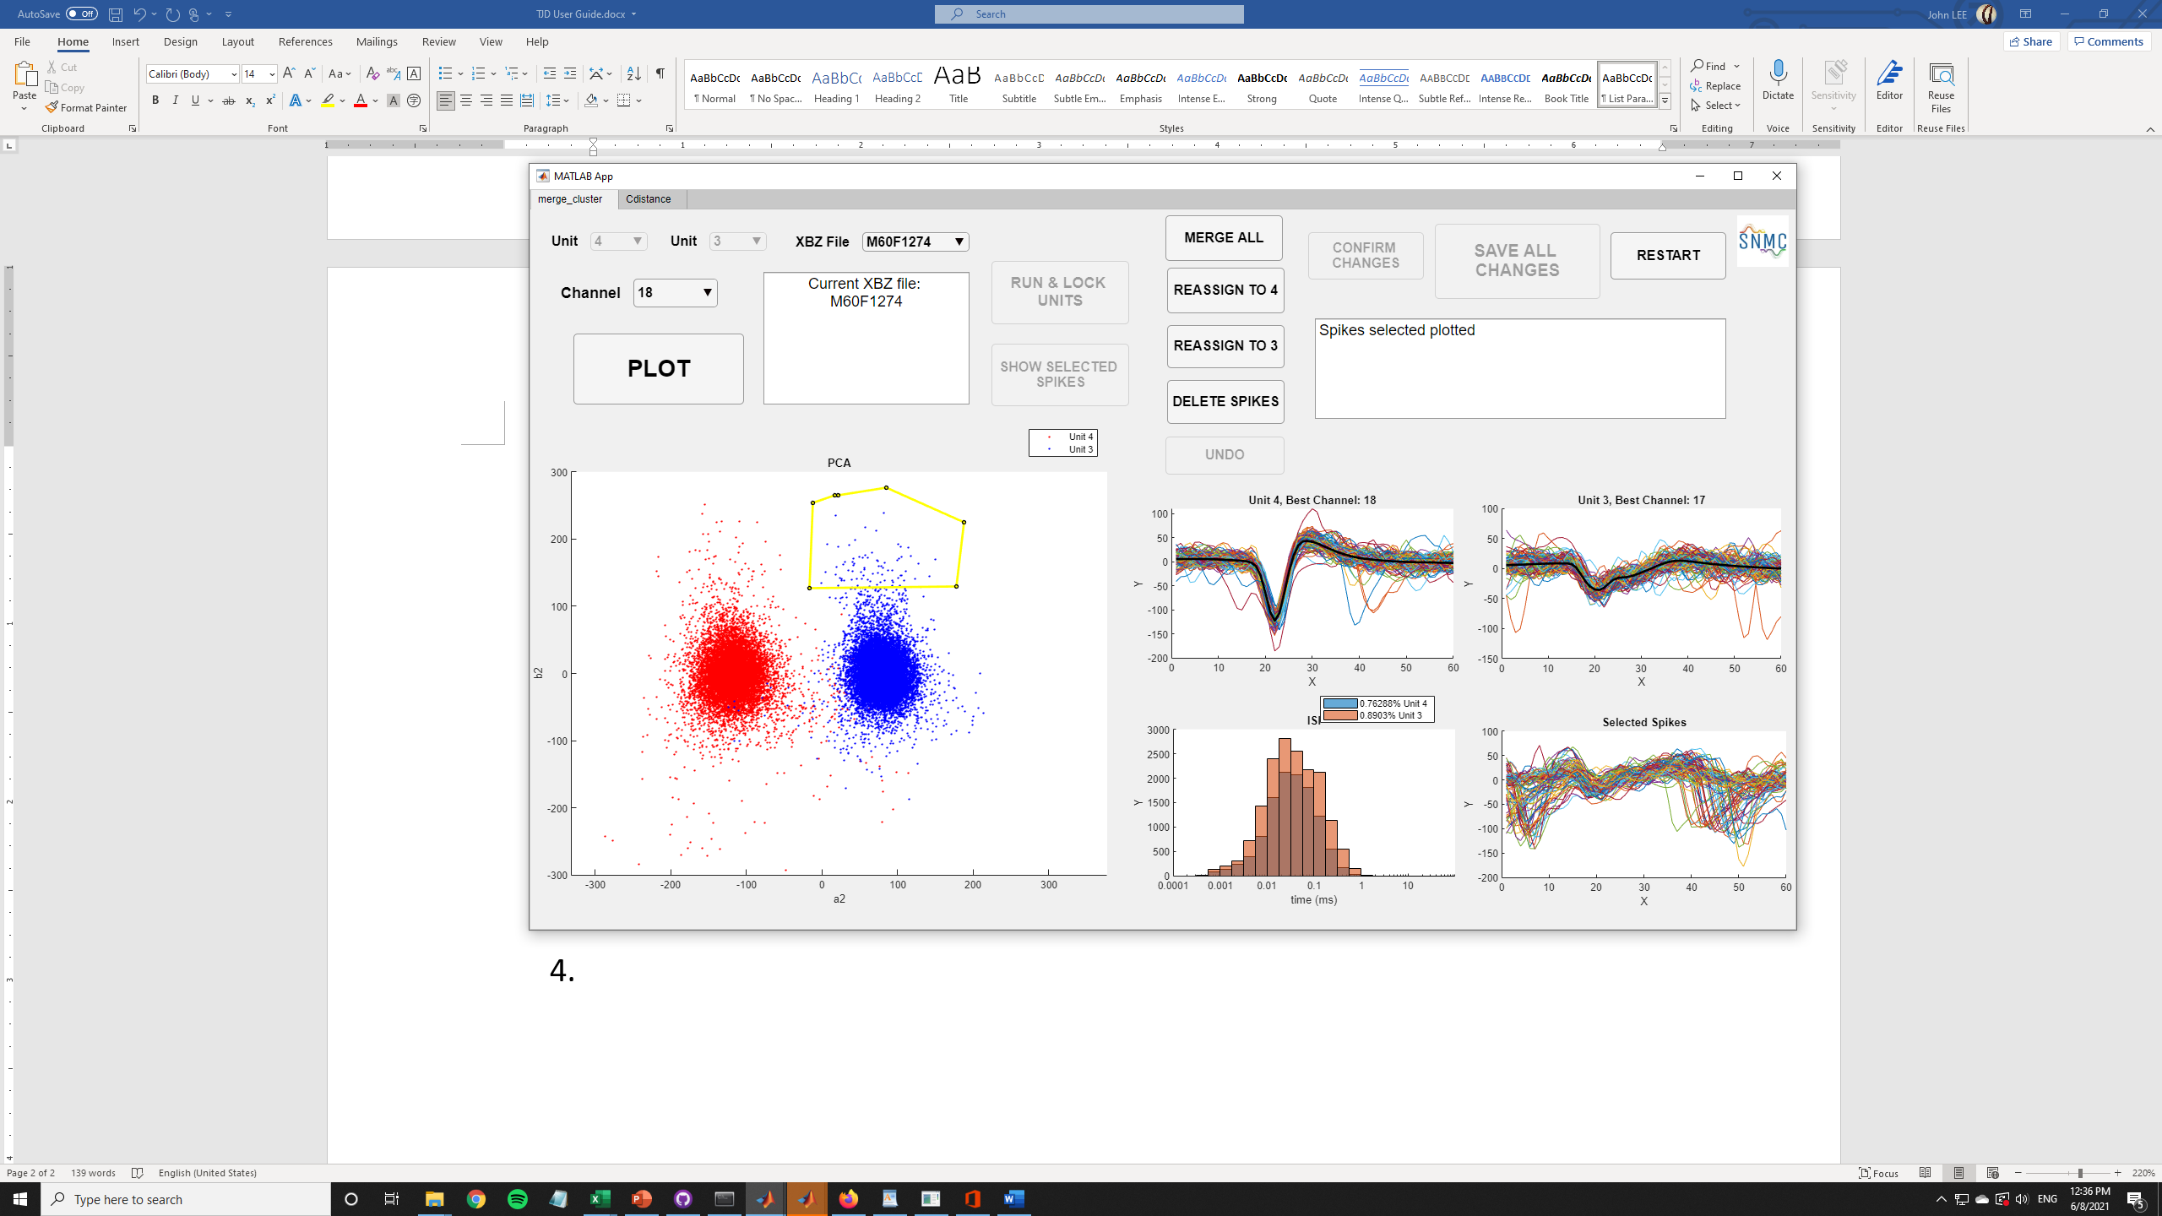

1. If you make errors during the data modification, you can always press the UNDO button to start again. This will not change the units selected at the beginning, it will only undo the changes previously made (like deleting or reassigning spikes).
2. Once you are done making changes, press CONFIRM CHANGES to save the data of that XBZ file. After this, you can select a different XBZ file and make changes to it. Please note: every time you press CONFIRM CHANGES you will be saving the data of that XBZ file, but you won’t be able to see those changes in the GUI if you select that XBZ file later, but this doesn’t mean the changes were not made. To double check the changes you can always look at the workspace variables.
3. When you finish modifying all the data you wanted to, press SAVE ALL CHANGES, this will save the data across all the XBZ files you previously modified. Once you press this button, press RESTART if you want to use the TJD GUI again.